###### Logo Black and White

PUCIT

Punjab University College of Information Technology

**Smart Shopping – Shop As You Scan**

**Version 1.0**

Table of Contents

Final Project Proposal 2

1.1 Project Title 3

1.2 Project Overview Statement 3

1.4.1 Project Goals 4

1.4.2 Project Objectives 4

1.5 High-level system components 5

1.6 List of optional functional units 6

1.7 Exclusions 7

1.8 Application Architecture 7

1.9 Gantt chart 9

1.10 Hardware and Software Specification 9

1.11 Tools and technologies used with reasoning 9

**1.1. Project Title**

**Smart Shopping - Shop As You Scan**

**1.2. Project Overview Statement**

Smart Shopping is a solution to transform shopper’s smartphone into a magical tool. No checkout counters, No manual payments, Safe & Secure. Shopper will install the Smart Shopping App and head to the nearest Super Market. One can walk through the aisles; scan Barcode on items and add to cart. Payment can be made directly from smartphone within the premises of Super Market. Once done with shopping, an associate will cross-reference the cart items with digital receipt from shopper's smartphone on the way out.

|  |
| --- |
| **Smart Shopping – Shop As You Scan** |
| |  |  |  |  | | --- | --- | --- | --- | | Name | Registration # | Email Address | Signature | | Arsam Kamran | 2014_UCS_344 | bitf14a020@pucit.edu.pk |  | |
| Project Goal:  A system that will facilitate shoppers hassle-free shopping as they will scan items and pay directly from their smartphone. It will eliminate time consuming long queues at checkout counters and retain shopper’s privacy. |
| Objectives:   |  |  | | --- | --- | | Sr.# |  | | 1 | Connecting to the store server. | | 2 | Scanning the product item. | | 3 | Calculating the total number of items in the cart. | | 4 | Generating the total bill. | | 5 | Paying the bill or scanning it at the counter. | | 6 | Generating E-Receipt | |
| **Project Success criteria:**   * Complete detail of the items added to cart will be shown * User will be able to add the item to the cart by scanning the barcode * System will be able to identify the item that is added. * Products will be added and a total bill will be calculated and the items will be shown in the list on the mobile phone. * E-Receipt will be sent to the user through mail or stored in the phone. |
| **Assumptions, Risks and Obstacles:**  If the database crashes or close network goes down, Smart Shopping App will not scan any item eventually becoming useless to users. |
| **Organization Address:**  N/A |
| Type of project: 📺Research 📺Development |
| Target End users:  Shoppers, Cashier, Associate and Manager. |
| Development Technology: 📺Object Oriented 📺Structured |
| Platform: 📺Web based 📺Distributed  📺Desktop based 📺Setup Configurations  📺Other_____________________ |
| Suggested Project Supervisor: Sir Idrees |
| Approved By: |
| Date:20-10-2017 |

## 1.4.1 Project Goal

A system that will facilitate shoppers hassle-free shopping as they will scan items and pay directly from their smartphone. It will eliminate time consuming long queues at checkout counters and retain shopper’s privacy.

**1.4.2 Objectives**

1. **Connecting to the store server**

User will connect to the wifi of the store through the phone.

1. **Scanning the product**

User will scan the product item through the store application on the phone and the product will be added to the list and the user will put it in the cart.

1. **Calculating the total items**

The application will be able to calculate the total no. of the items that are added in the list and are present in the cart. It will also tell the specifications of the items like their price and weight etc.

1. **Generating the total bill**

The application will generate the total bill of the items that are present in the list.

1. **Paying the bill**

The user will scan the code of the application at the counter and the total bill with the items list will be displayed to the person at the counter and the user can pay the bill in cash. OR the user can add his/her credit card and pay the bill through the application.

1. **Generating E-Receipt**

Application will generate the receipt of the shopping list and will also mail the user about the shopping with the receipt that he has done.

## 1.5. High level system components

1. Registration
2. User authentication
3. Scan different item
4. E-cart
5. Add and remove items from e-cart
6. E-bill
7. Make payment through credit card
8. User has wallet
9. Cart and payment verification
10. Checkout

## 1.6. List of optional functional units

1. Login
2. Reward points integration
3. Send/receive money to/from any other user
4. Map of shopping mall
5. Customer feedback and suggestions portal
6. Product reviews

**1.7. Exclusions**

1. Routers and switches will not be included in resources
2. System will not estimate number of staff required
3. Any type of hardware failure in the system

**1.8. Application Architecture**

* **Presentation Tier:**

Android, Java

* **Application/Logical Tier:**

Web Server(Azure), C# (For Apis)

* **Data Tier:**

SQL

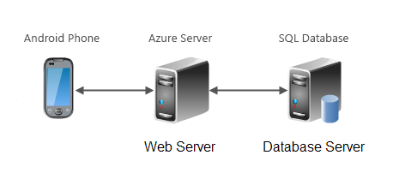

**1.9. Gantt chart**

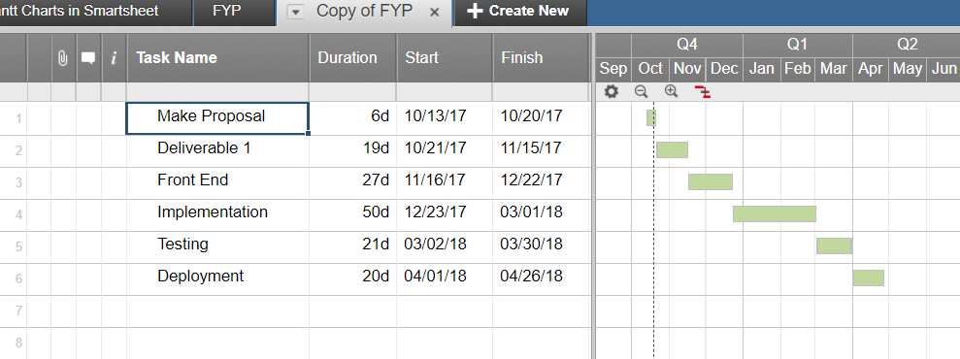

**1.10. Hardware and Software Specification**

Any Android phone that supports 4.x Jelly Bean software is able to use and run our application.

**1.11. Tools and technologies used with reasoning**

|  |  |
| --- | --- |
| Tools & Technologies | Reason to use |

|  |  |
| --- | --- |
| 1.Java | We use Java because of its vast array of 3rd party libraries,  Excellent performance, Excellent specification, Sturdy garbage collection, Managed memory, Native threads.  We will be making a native android application so we will be using java for that. It will help us in making it properly applicable for every latest Android phone there is. |
| 2. C# | We will be using the Microsoft Azure Host Server to write the Api’s that will connect the main Android application to its database. |
| 3. SQL | For the Database and its design and storing all the information of product items and their detailed information we will use the SQL database. |
| 4. MS Project | We are using it to create Giant Chart, project plan to manage our project. |
| 5. IntelliJ idea IDE | We are using spring with Android Studio for java and IntelliJ idea supports this framework it manageably and efficiently. |